**User Interface Case Study Report On**

**“Wedding Wale”**

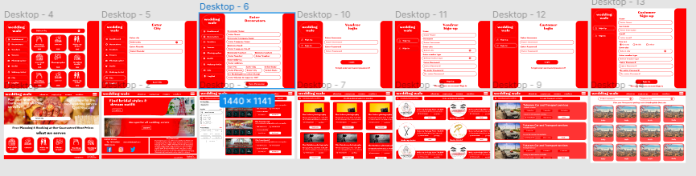

SUBMITTED BY

# 20-Mishra Shivam Vivek

Under the guidance of

# Prof. Neha Lodhe

## Late Shri. Vishnu Waman Thakur Charitable Trust’s

VIVA INSTITUTE OF TECHNOLOGY

#### Shirgaon, Virar(East)

**2021-2022**

# Index

|  |  |
| --- | --- |
| **Content** | **Page No** |
| **Project Proposal and Requirement Gathering** | |
| 1. Introduction to project | 3 |
| 2. Objectives | 3 |
| 3. A history of the problem as it relates to user experience | 3 |
| 4. A concise summary of your project’s requirements | 3 |
| 5. explain your solution to the problem and how you will execute it | 3 |
| **Analysis** | |
| 1. Briefly state the problem(s) that the project will seek to solve. | 4 |
| 2. Considering the users point of view (problem statement or user needs). | 4 |
| 3. identify what the users goals are, and what obstacles lie in the way | 4 |
| 4. Write a user analysis (Design a persona) | 5 |
| 5. Task analysis (identify three tasks of the chosen problem) | 5 |
| 6. Write up domain analysis clearly, concisely, and completely | 5 |
| **Design** | |
| 1. Explain the Scenario | 6 |
| 2. Sketch the scenario (use storythat.com) | 7 - 8 |
| 3. Draw a mental model | 9 |
| **Prototype** | |
| 1. Paper prototype | 10 - 12 |
| 2. Wireframe | 13 |
| **Implementation** | |
| Design UI 3 pages | 14 - 19 |

**Project Proposal and Requirement Gathering**

## Introduction to project

A few months ago, my friend asks me to make one good website for him. where people are come and book different services which is required for their wedding.

## Objectives

The wedding wale website only goal is to make marriage need easier. Like one place where people come and get all services which is basically need in wedding. Like wedding hall, pandit, catering and cameraman. This are some basic requirements of wedding

## A history of the problem as it relates to user experience

According to our research no website and app are available for this type of wedding fulfill requirements. currently people don't have any option where they book wedding halls, Makeup artist and wedding dress at one place.

# 4. A concise summary of your project’s requirements

This basic thing of making wedding easy, comfortable and in budget. And people are don't feel trouble booking their wedding related services on that date

# 5. Explain your solution to the problem and how you will execute it.

We have made Dog Diet App, app contain healthy diet recipes and balanced diet plan for the dog. We have made user friendly experience in our application so user easily prepared diet for his/her pet.

# Analysis

## Briefly state the problem(s) that the project will seek to solve.

It is kind of ironic that one of the most exciting times of your young, loved-up life can also be some of the most stressful times. Though we sometimes wish it was as simple as booking a West End restaurant for dinner, things start getting a lot more complicated when you start calculating the seating arrangements and trying on outfits. Thankfully, there are a number of wedding planning problems that occur time and time again, meaning that by learning from collective experience, you can avoid them.

Of course, we would know! As [**Wedding**](https://www.themontcalmclub.com/membership-597.html) **Wale**know very well, there are several venues available within our hotels spread throughout London. That means we see (and help!) couples from all over the world arrange their big day.

1. **Considering the users point of view (problem statement or user needs).**

A classic problem people planning their wedding face is that their guests from out of town aren’t able to stay overnight. This is 100% avoidable in London, though, given the sheer number of[**London hotel packages**](https://www.themontcalmclub.com/packages-740.html) and [**London hotels special offers**](https://www.themontcalmclub.com/offers-372.html). Last-minute bookings can be risky, though, so to stop accommodation from being an issue during your planning process, make sure your guests know the venue or at least general location as soon as possible.

If there is one thing that will insight immediate dread in any bride or groom, it is the prospect of a stained wedding dress or ripped suit at a point where it is too late to do anything permanent. However, there are a few tricks and tips on how to make cosmetic repairs on the big day. In a little bag in your dressing room, keep the following: white and black fabric tape (or whatever colour the groom’s suit is). While this is not quite a repair to a rip, it is hardly noticeable and a great make-shift technique that will at least ensure the hole doesn’t get any bigger, caught up on anything, or become visible in pictures. Another useful hack is to keep a compact pot of stain remover. Remember: the quicker you attend to a stain, the easier it is to remove. So, without making too much of a fuss, if you end up with a splodge of red wine down your torso, it is best to nip off and sort it out ASAP. Other NB things to keep with you are plasters for uncomfortable shoes and blisters, as well as some makeup wipes to touch up any casualties after a successful round of speeches.

1. **Identify what the users goals are, and what obstacles lie in the way**

Marriage is happiest day of any person. But sometimes people not able to book there favorite hall and cameraman. some time it's difficult to find but some time there are not available on that day.

1. **Write a user analysis (Design a persona)**

|  |  |  |
| --- | --- | --- |
| **Profile Photo Deatails** | **Bio** | **Goals** |
|  |  |  |
| **Ms. Alex**  **Age 58**  **Occupation : Doctor** | Alex is one of the good doctors and working from last 30 year. he has one daughter and their daughter loves someone and ready to marriage his lover.  Alex wants his daughter happy. And he to trying find good hall, marriage dress and catering to make his daughter marriage successful and big wedding. | Finding the best hall, catering, makeup artist and cars to marriage of daughter. |
| **Frustrations** |
| It is headache to find good marriage hall, catering, makeup artist, cars and other service which is need in wedding. |
| **Children : One Daughter** |  |  |

# Task analysis (identify three tasks of the chosen problem)

1. Book Service :- If you are user then check out all service which is need you and check it is availability or not and book that service.
2. Direct Connect with Service Provider :- On this website we can directly contact with the service provider.
3. User Friendly UI :- It easy for accessing the service and check there availability on that day.
4. **Write up domain analysis clearly, concisely, and completely**

My friend asks me to create new website where peopled book wedding related service. After asking by my friend, I am start working research on that type of site.

After research I was not found any Web-Site and app. then I start working on it wedding wale and it is requirement is good and it is good Web-Site for all people. where one place you can book many services Web-Site

# Design

* 1. **Explain the Scenario**

Designing the website has been a challenging and rewarding journey. It was clear from the onset that the major challenge will be to make people interested in something that wedding services. I where one place you can book many services Web-Site. The wedding wale website only goal is to make marriage need easier. Like one place where people come and get all services which is basically need in wedding. Like wedding hall, pandit, catering and cameraman. This are some basic requirements of wedding

What are the next steps?

* Deep research about specific features
* Usability test of the prototype with users
* Improve user flow
* A comprehensive business model

# Sketch the scenario (use storythat.com)

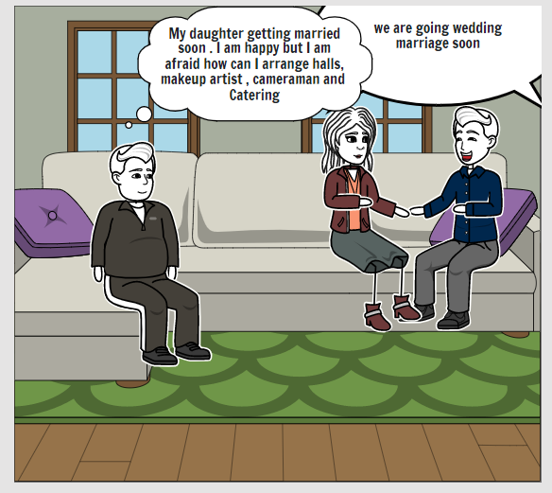

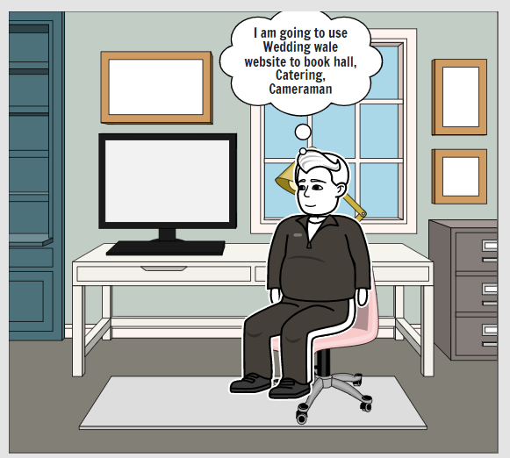

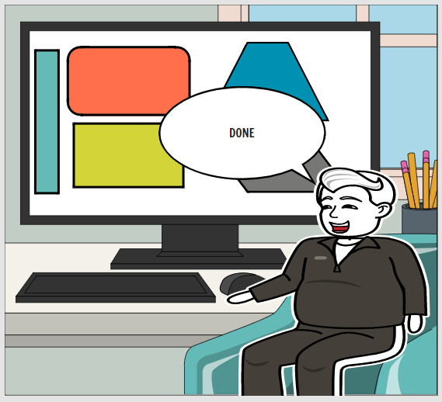

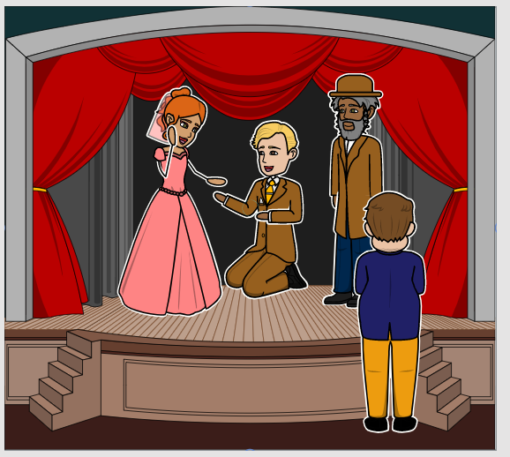

* 1. **Draw a mental model**

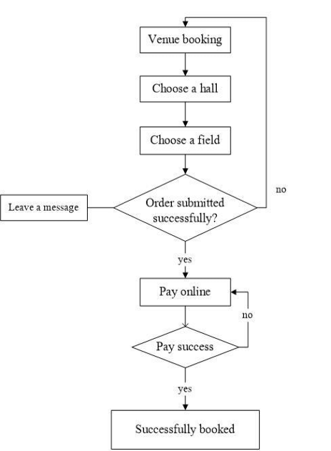

# Prototype

* + 1. **Paper prototype**

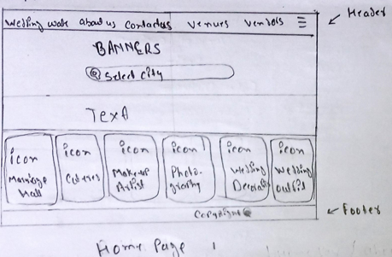

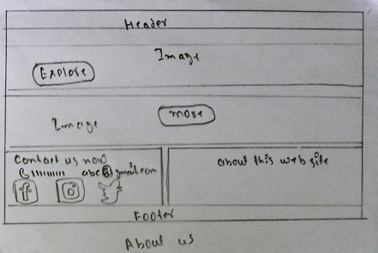

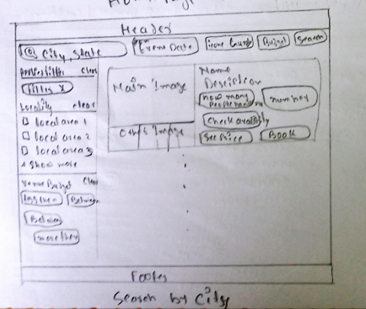

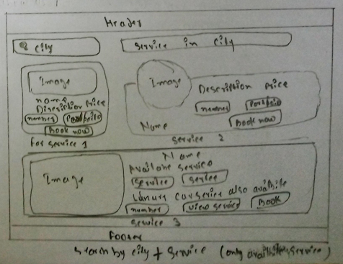

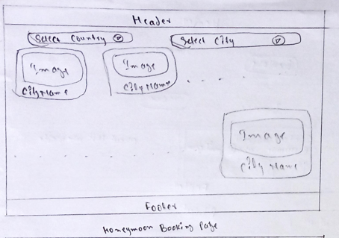

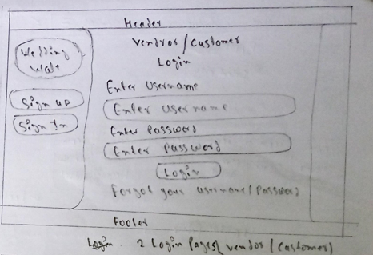

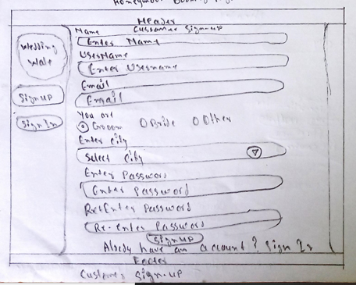

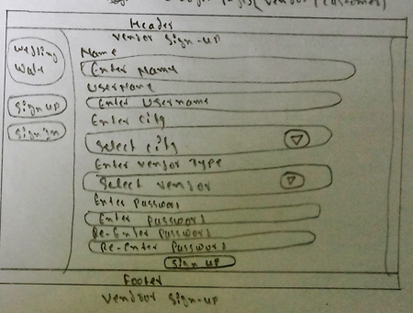

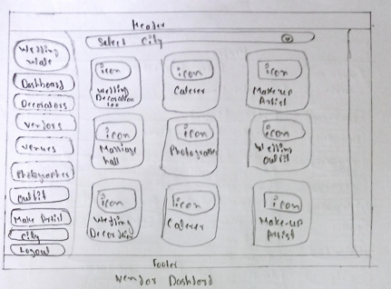

**2. Wireframe**

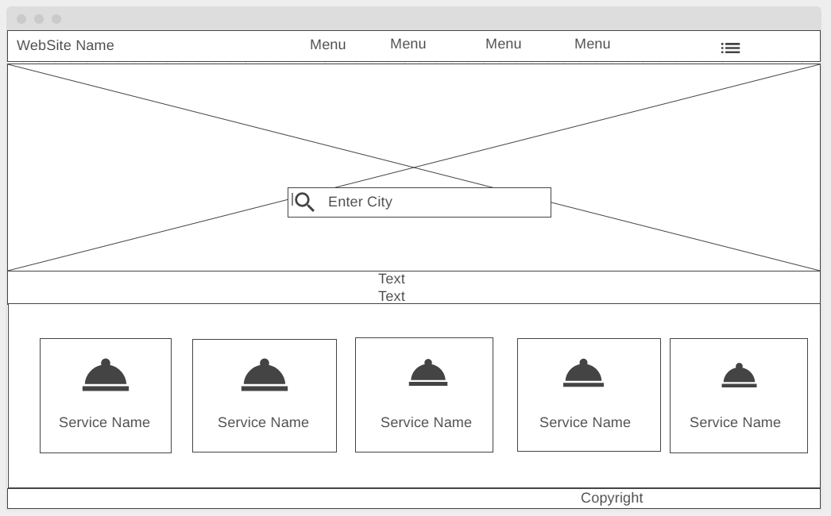

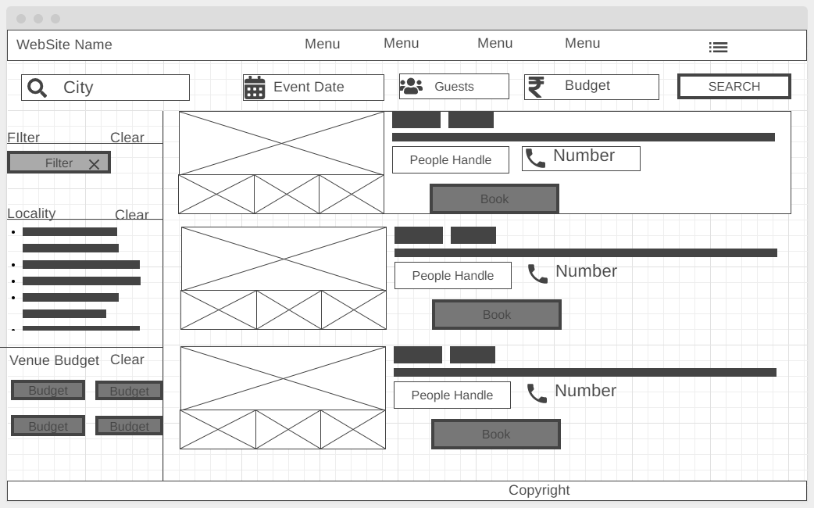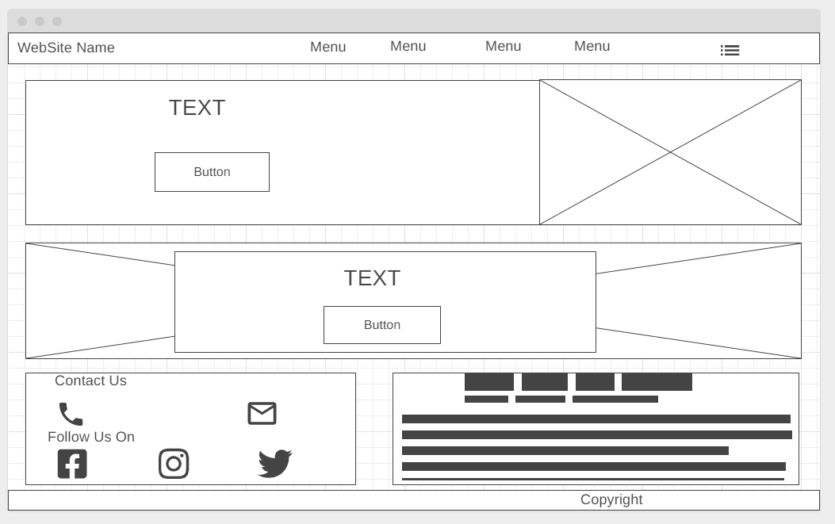

# Implementation

## Home Page

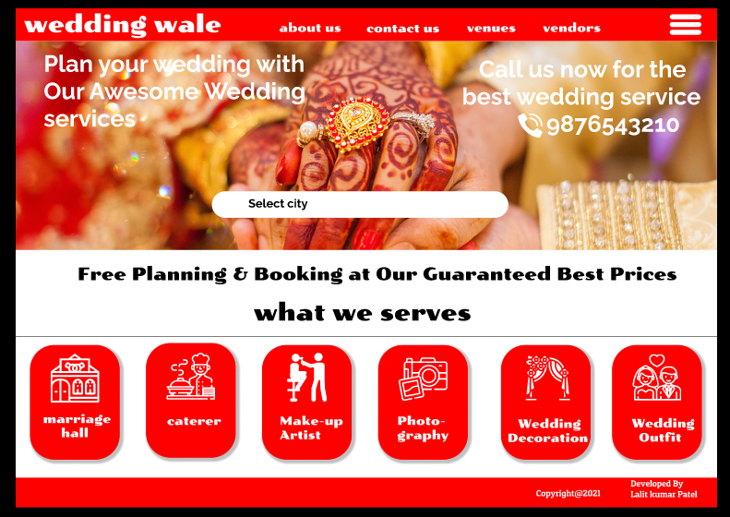

## About Us Page

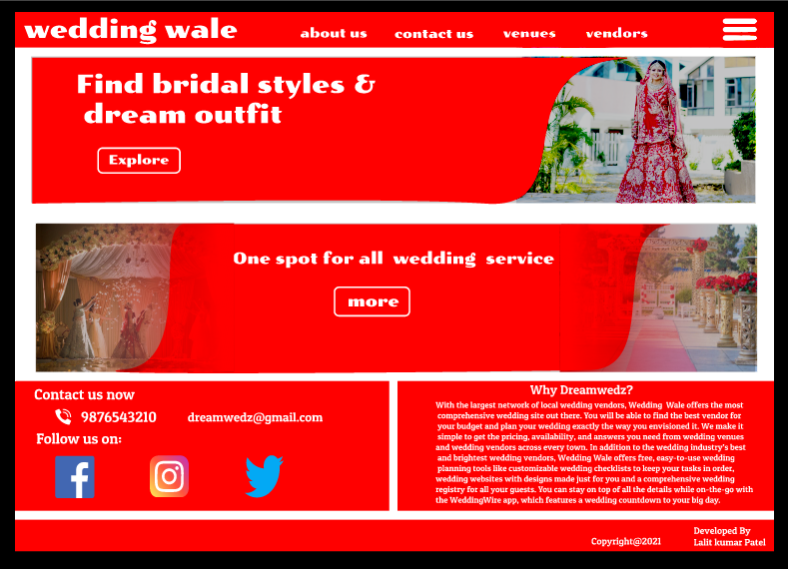

## Search By City

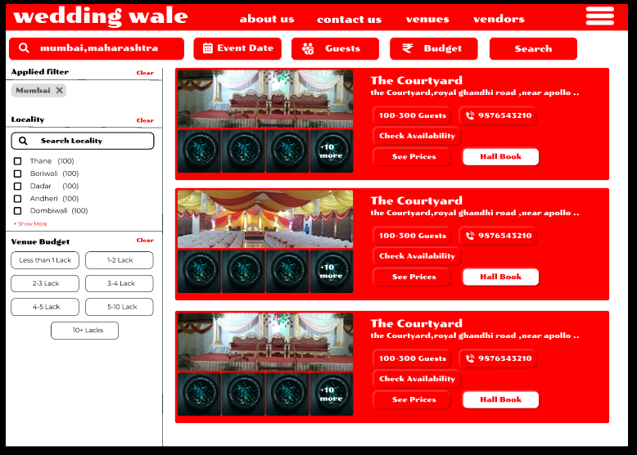

## Search Camerman

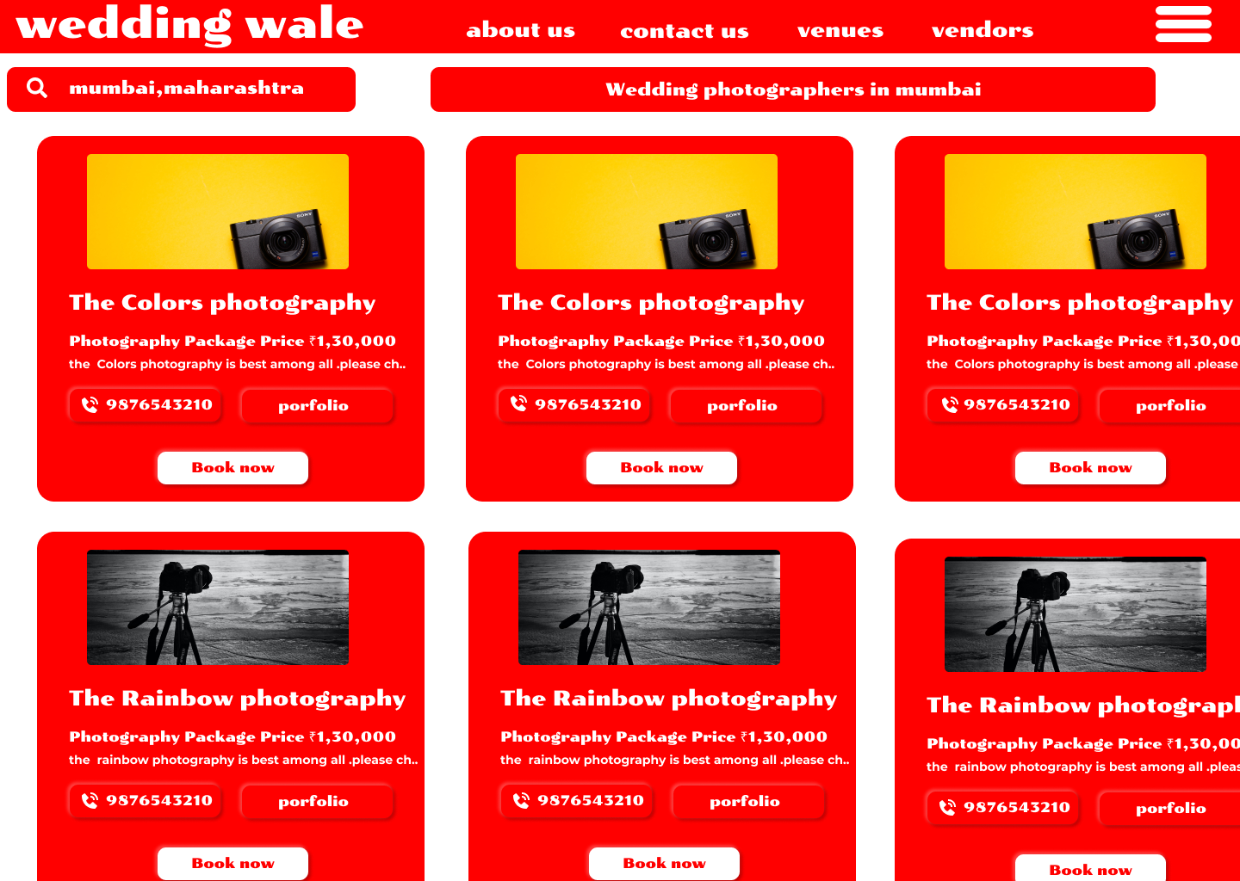

# Search Makeup Artists

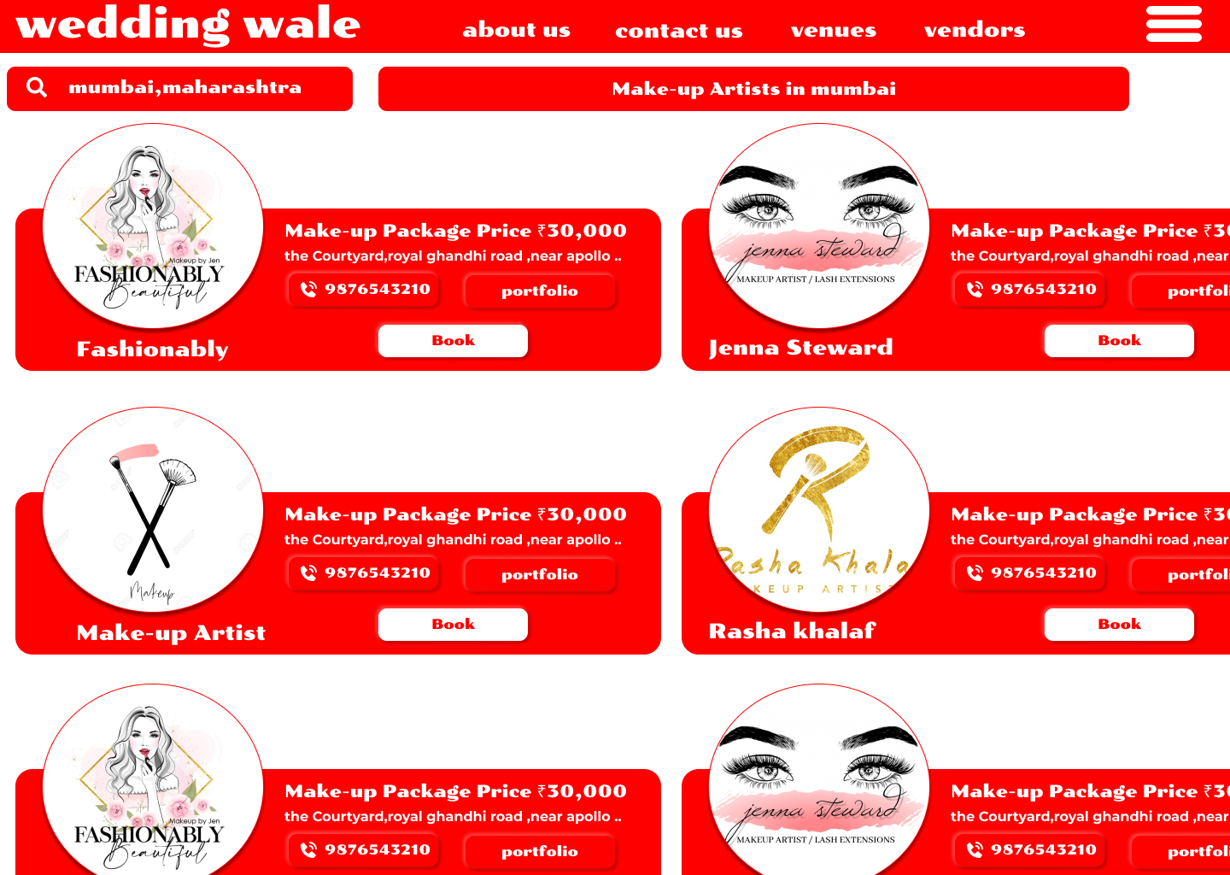

# Car and Transport services

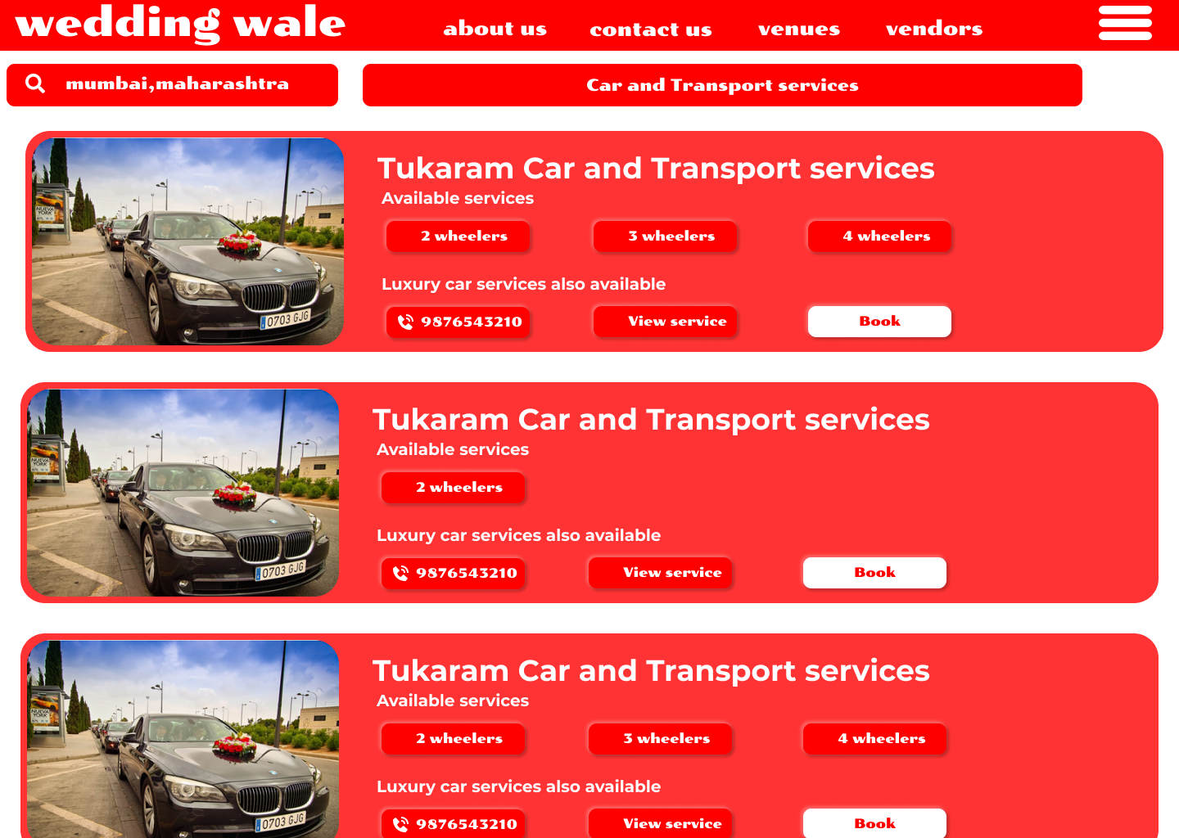

# Customer Login

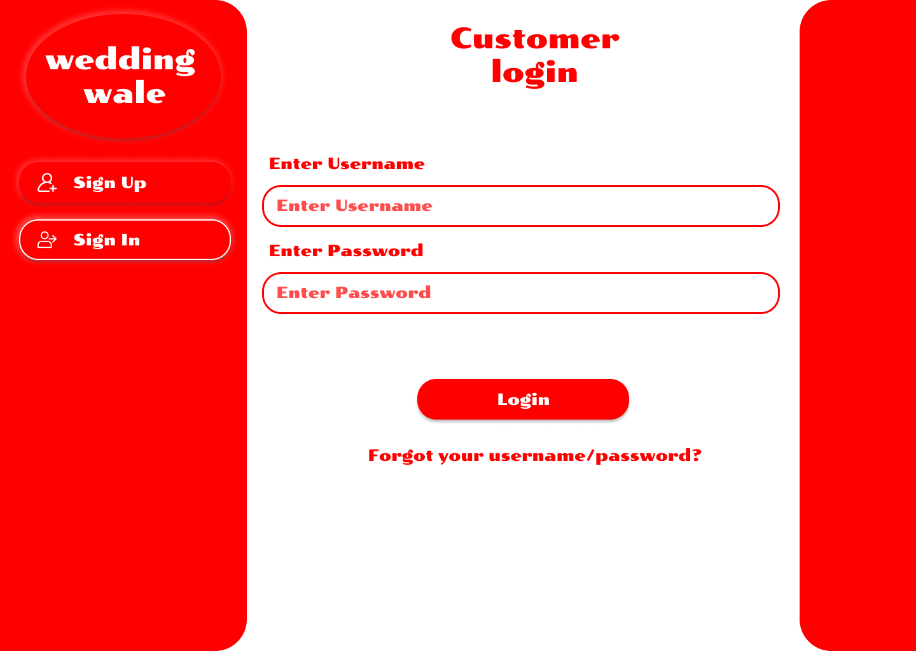

# Customer Sign -Up

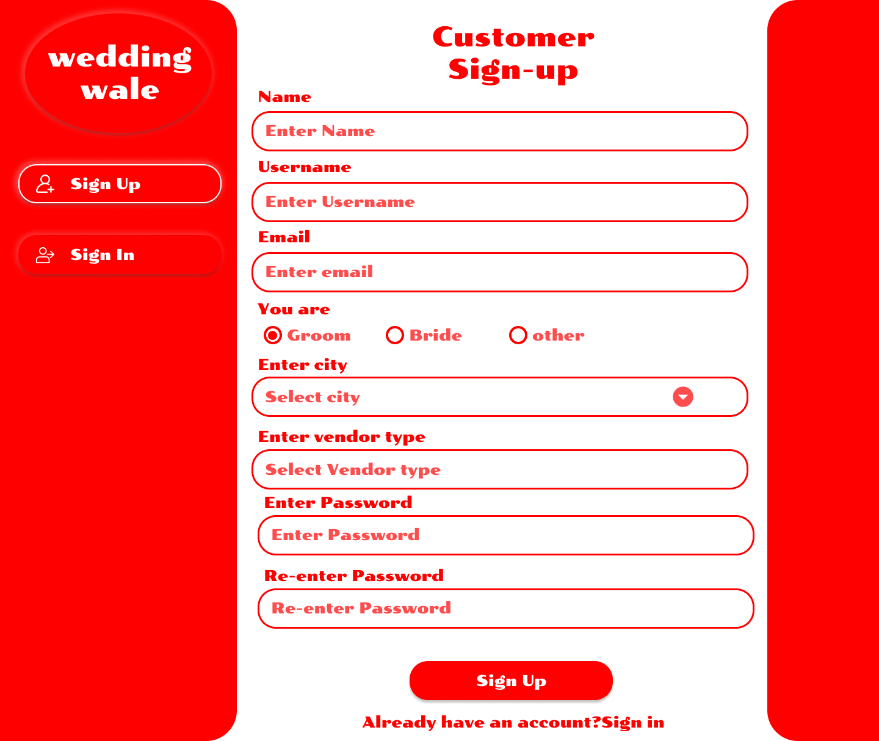

# Vendror Login

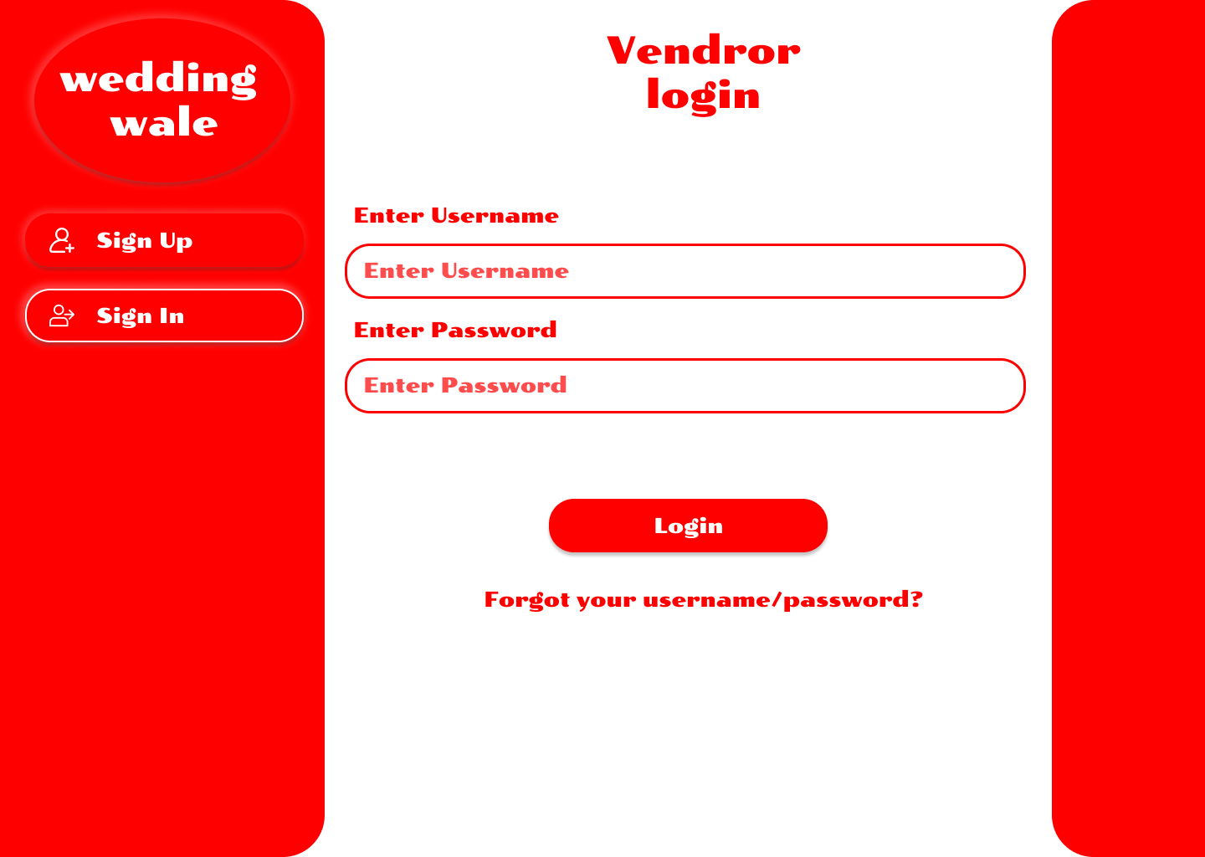

# Vendror Sign-up

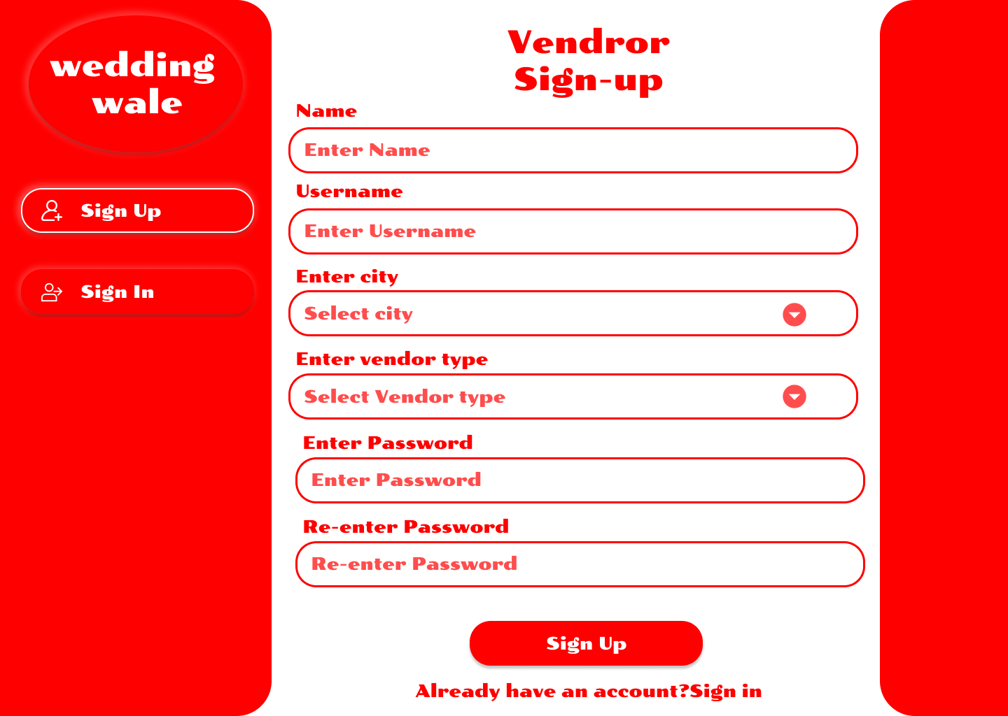

# Vendror Dashboard

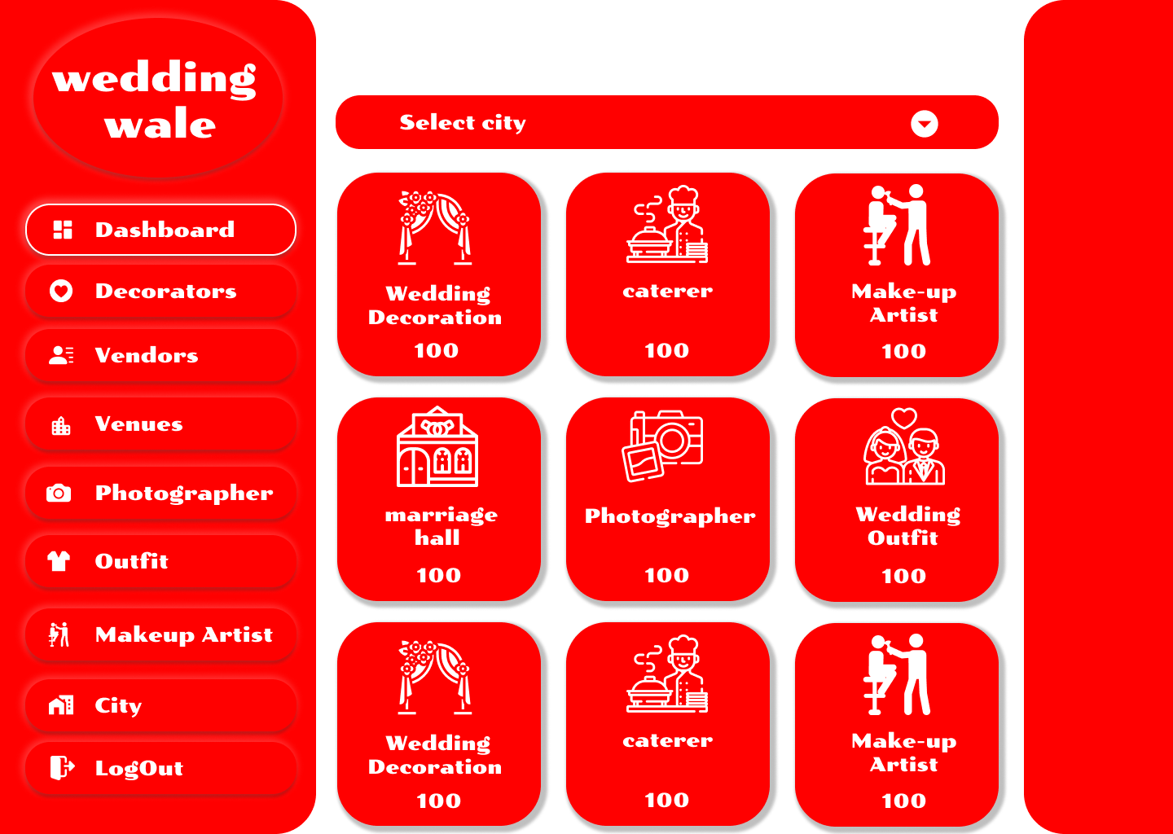

# Vendror Decorators Details

